Proxy:

Fidler is used as a proxy:

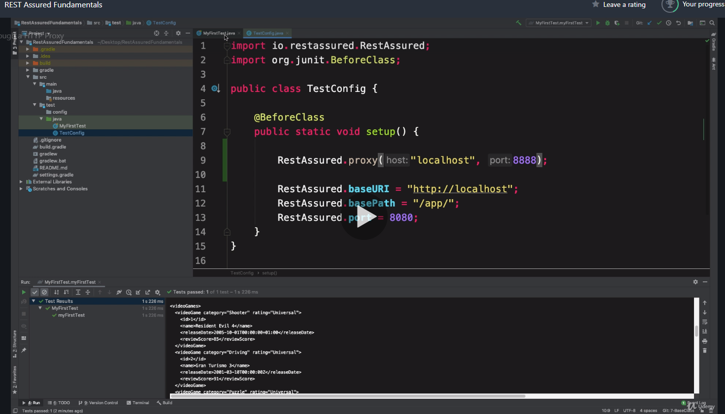

Setting up **RequestSpecification** in base class and tying it up with the RestAssured

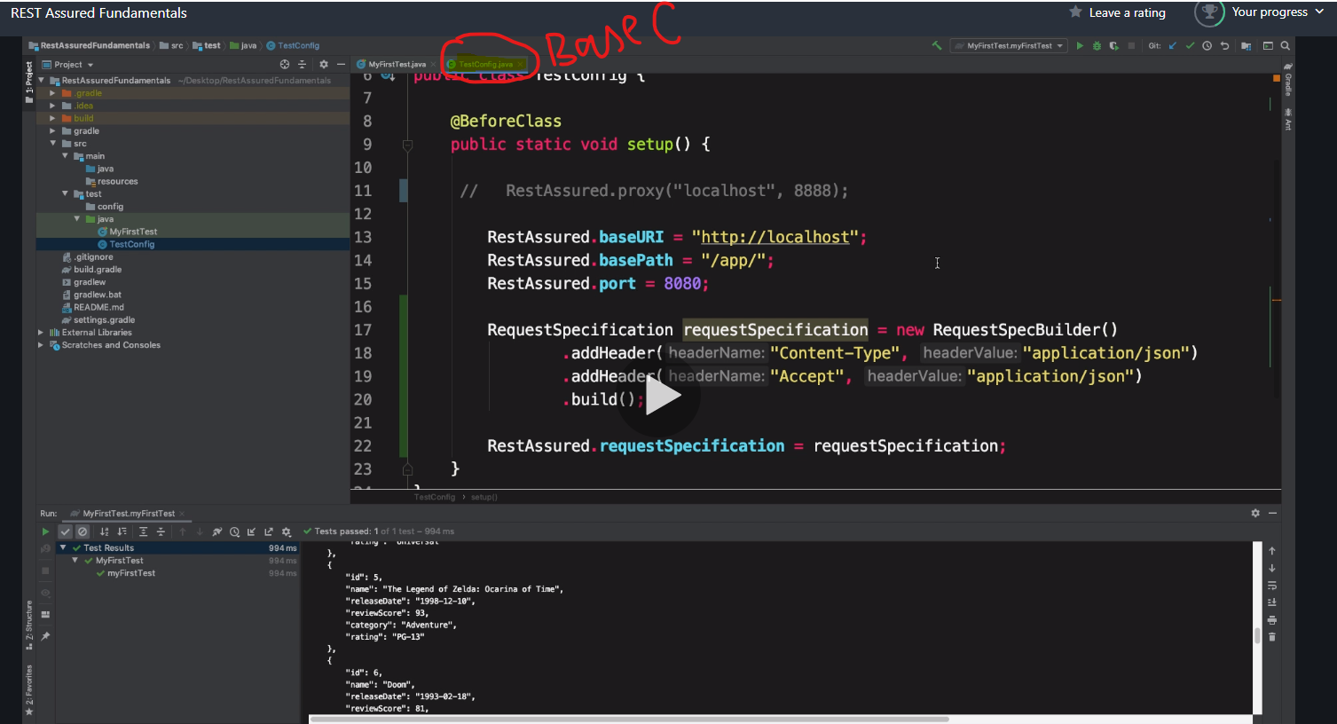

Set the request specification in super class to set the actions that we need to perform before each test.

**ResponseSpecifications** are actions that we take after every test for eg. Status code, content type etc

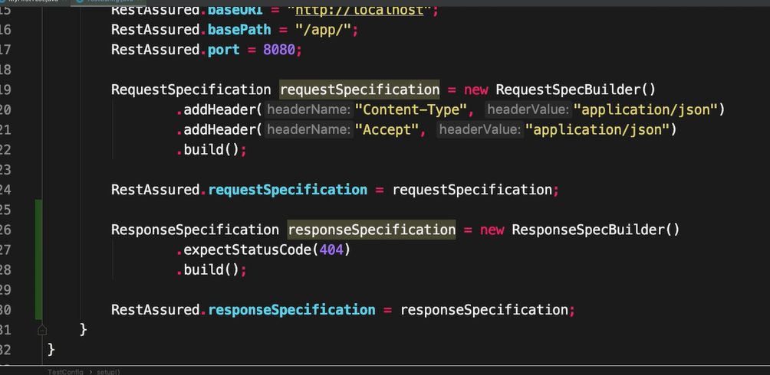

**Seting up base class with Req and Res spec

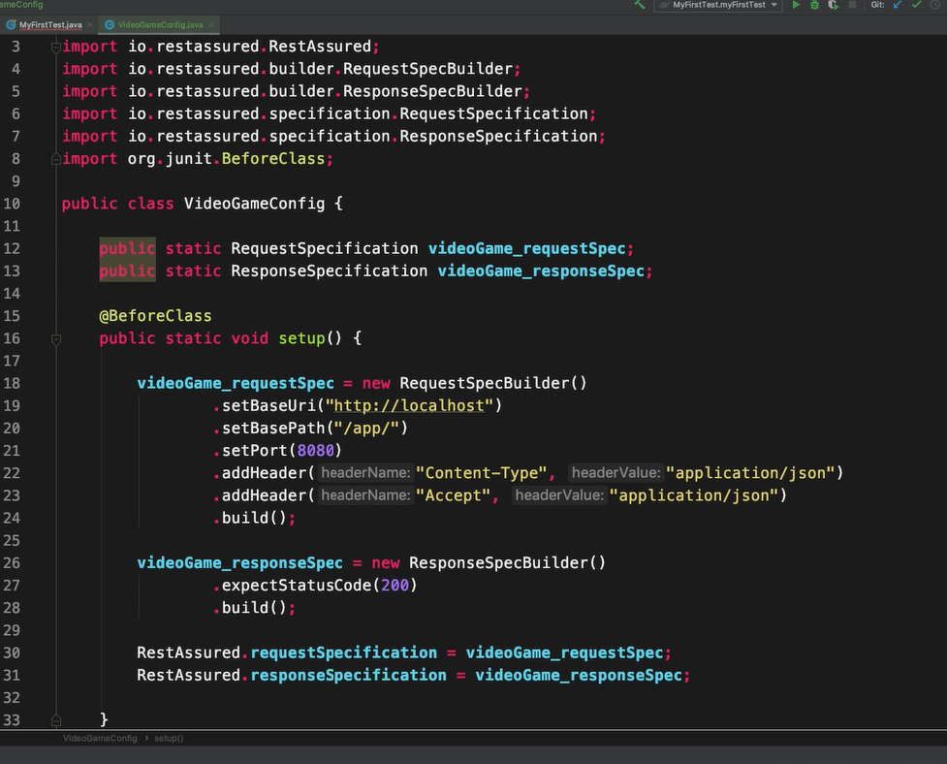

**End Points management in an interface: so that s there is any change in the end points we can handle it through intercase.

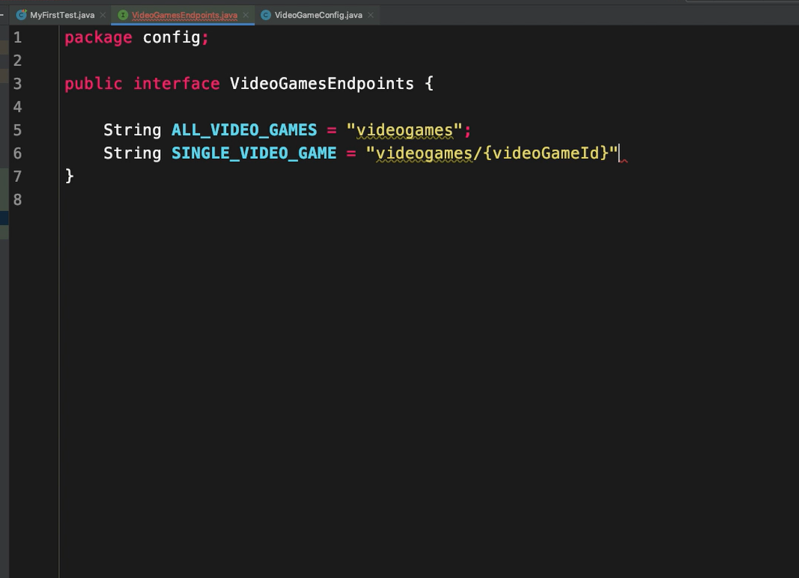

Test with endpoints

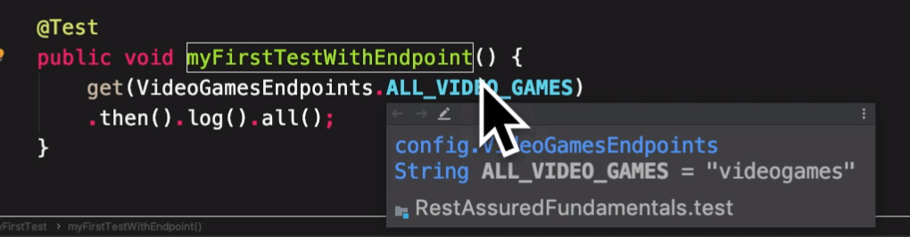

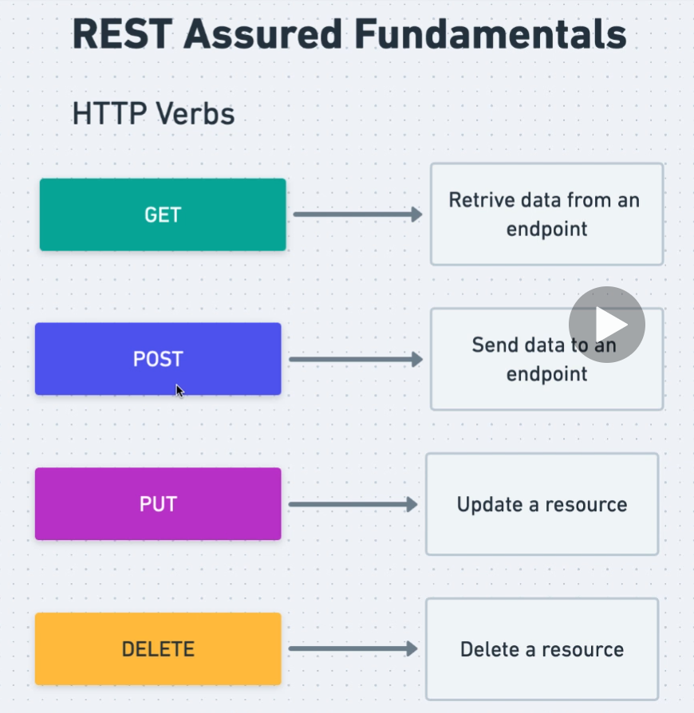

**Making a GET request

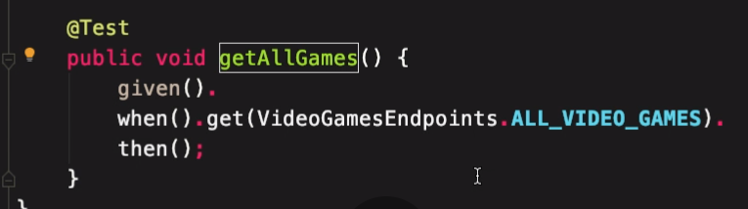

**Making a post Request with json body

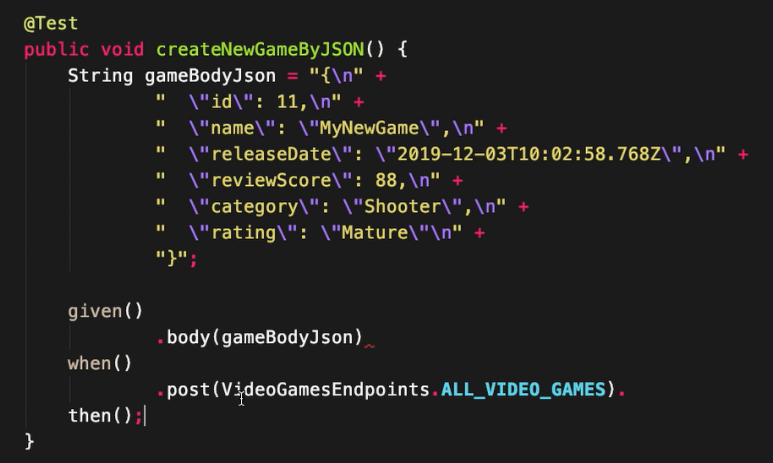

**Making a post request with xml

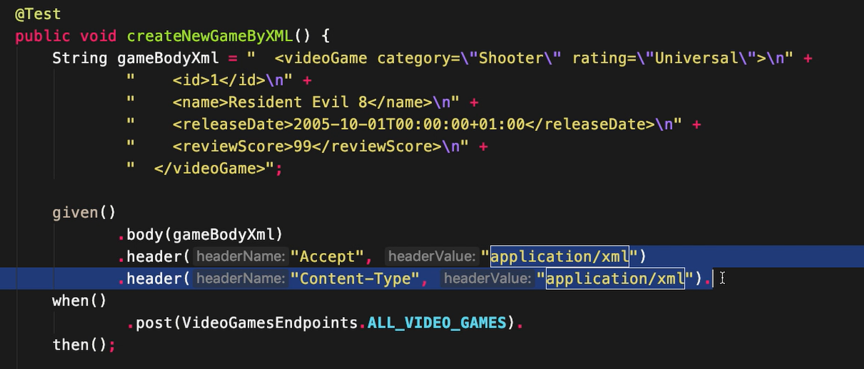

The .header mentioned in Test method overwrites the default headers of json type mentioned in base class.

**Making put requests

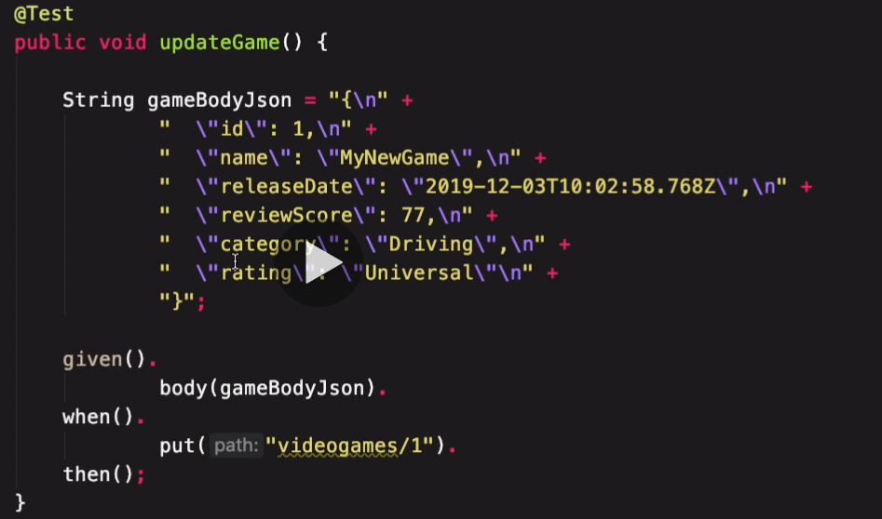

**Deleting an resource

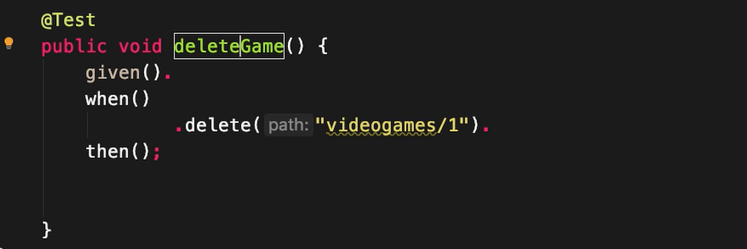

Delets game 1

**Path parameter:

We specify the path parameter in test only.

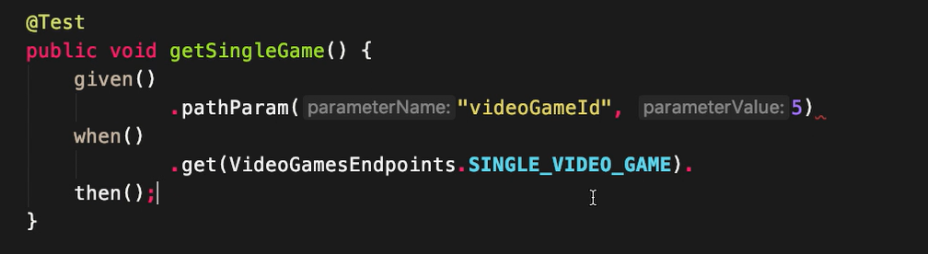

It will update the variable part of SINGLE_VIDEO_GAME by pathParam

**Creating a new base class with x-auth

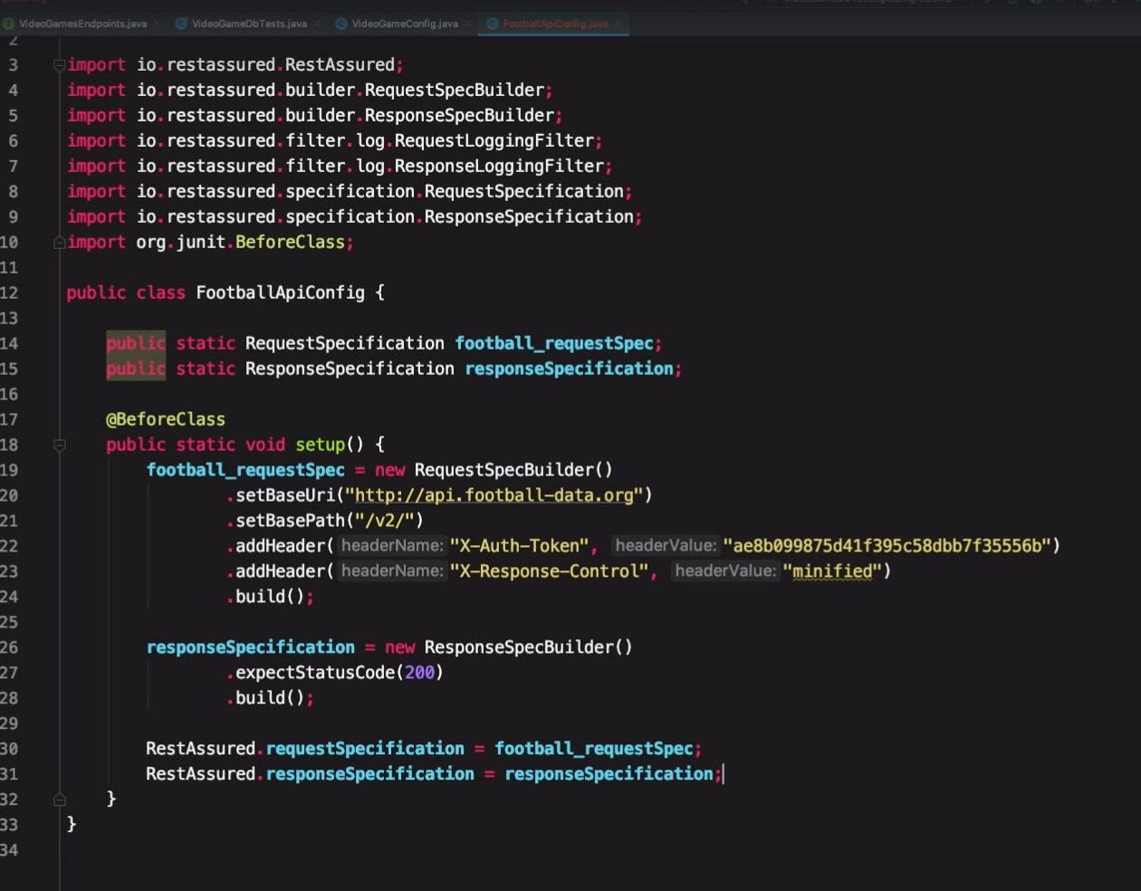

QueryParam has a ? mark in URI where as path param does not.

**Setting a query param:

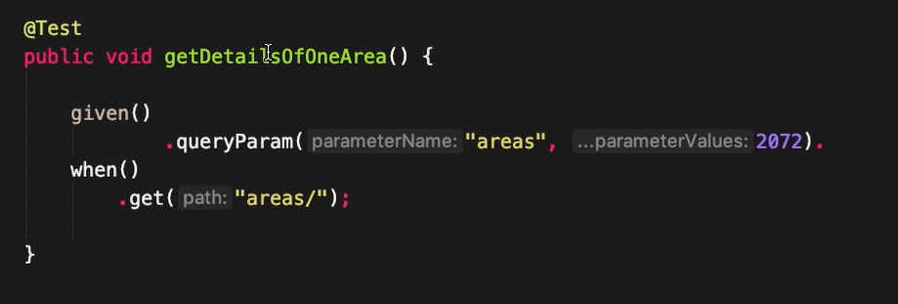

**Extracting data from response body.

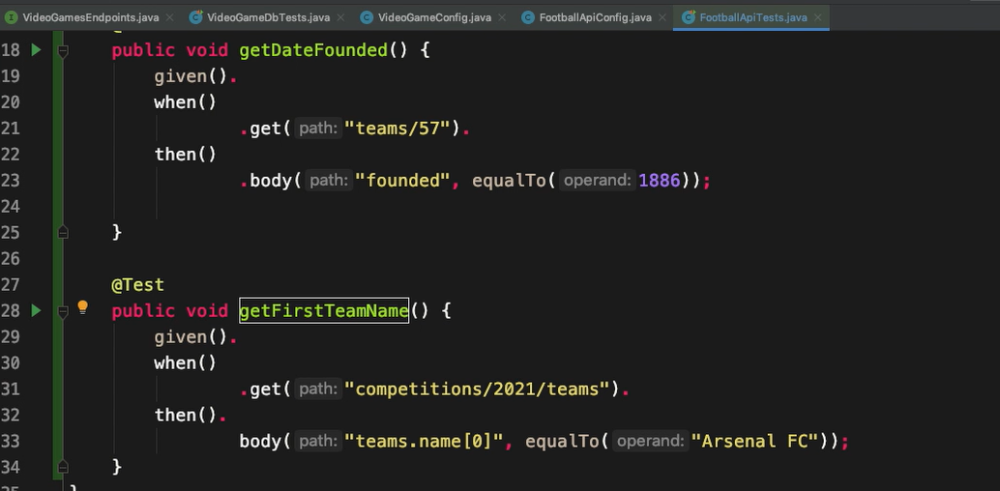

** Extracting the body in a variable and use later

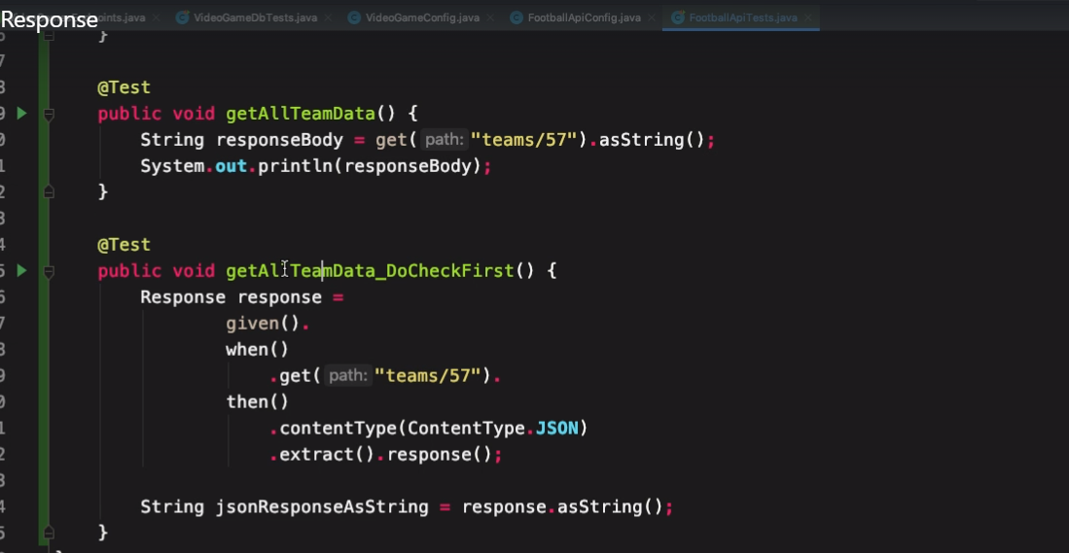

**Extract headers from response

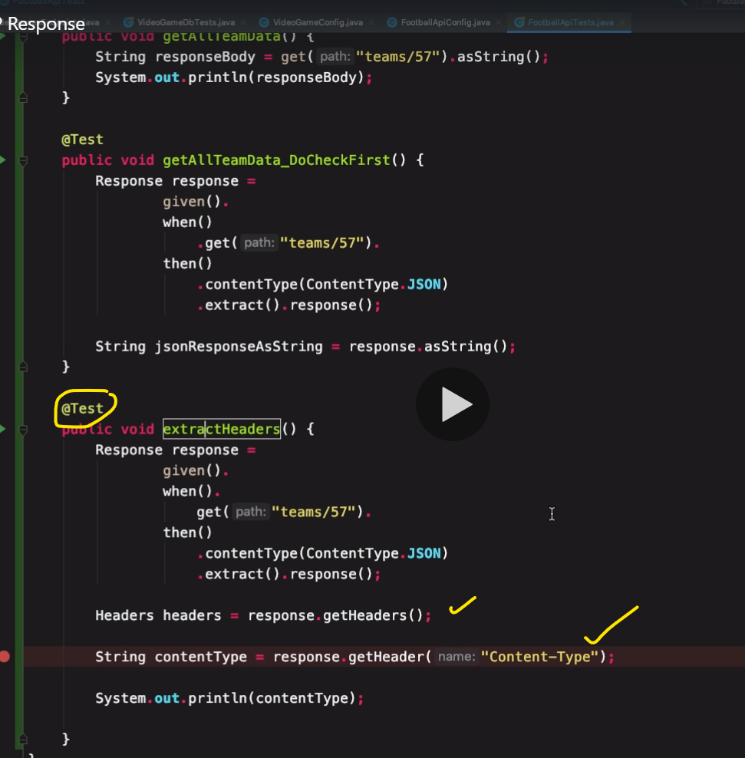

**Extract the json response with json path

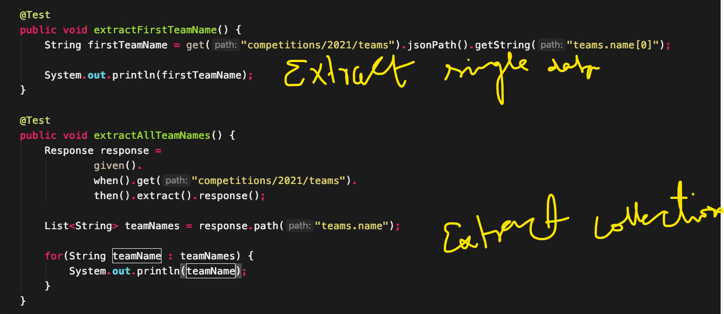

**\*\*Serialization in RestAssured**

VideoGame class created by online JAVA POJO class creator.

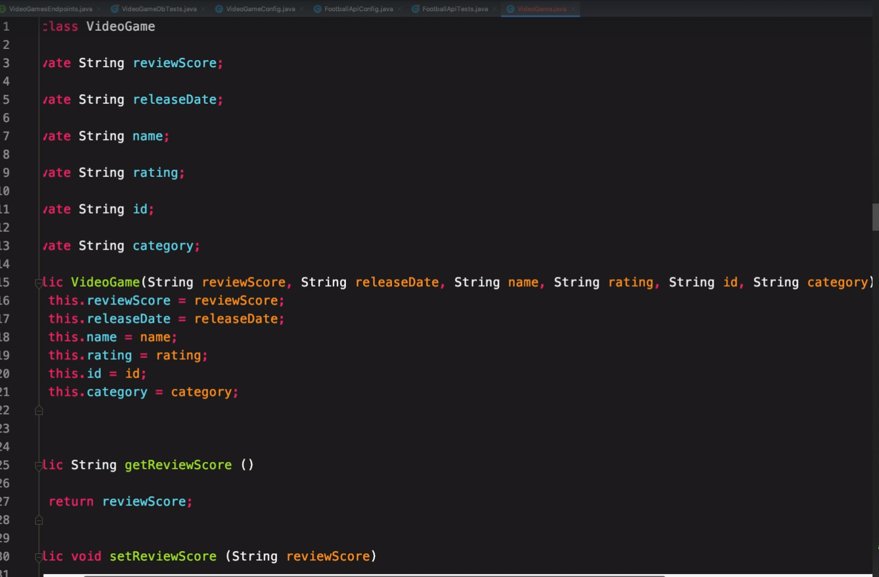

Create the object of above class with parameters and make a POST request.

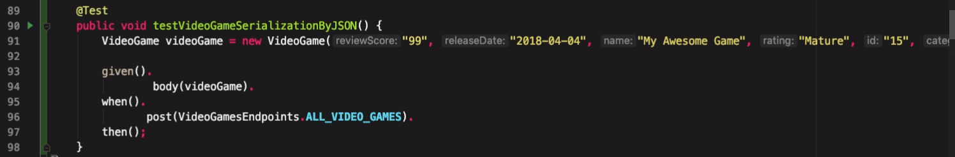

**Validating Response anainst XML schema:**

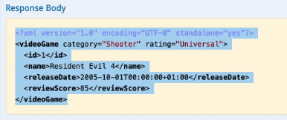

Generate schema for xml

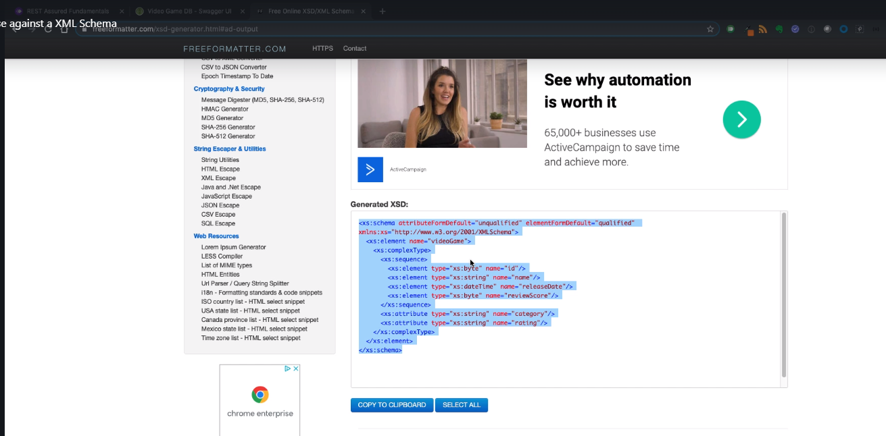

Create an xsd file in framework

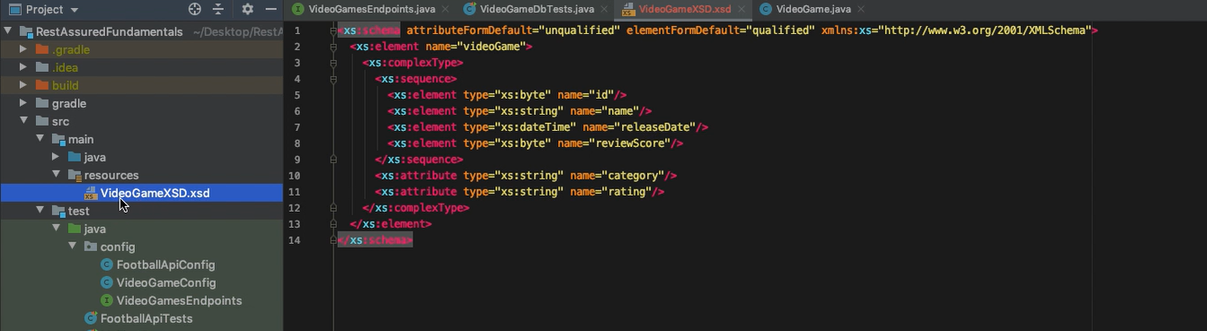

Run test

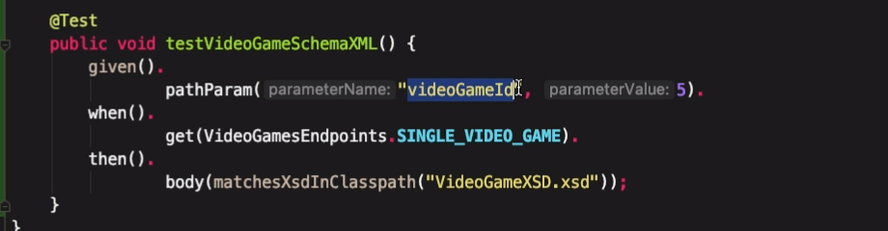

**Validating response against a json schema**

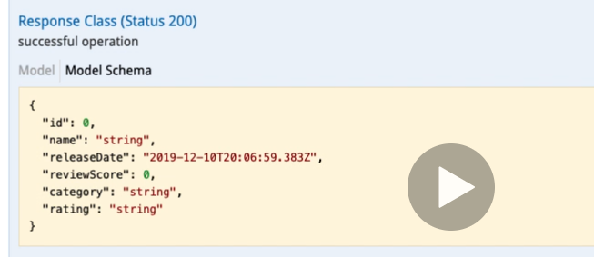

Generate schema online

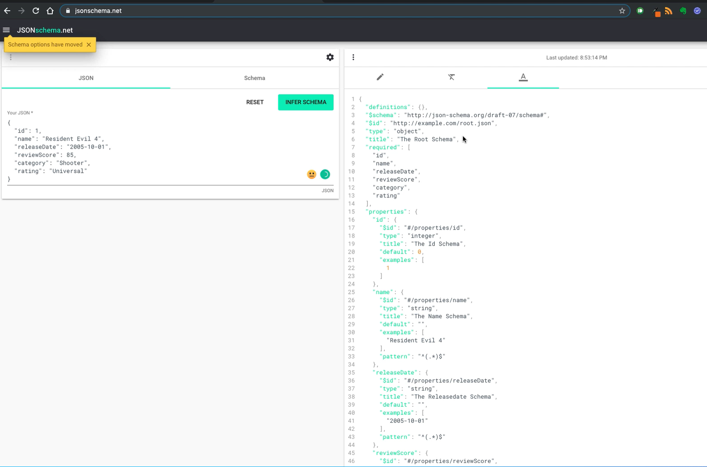

Create a schema in framework

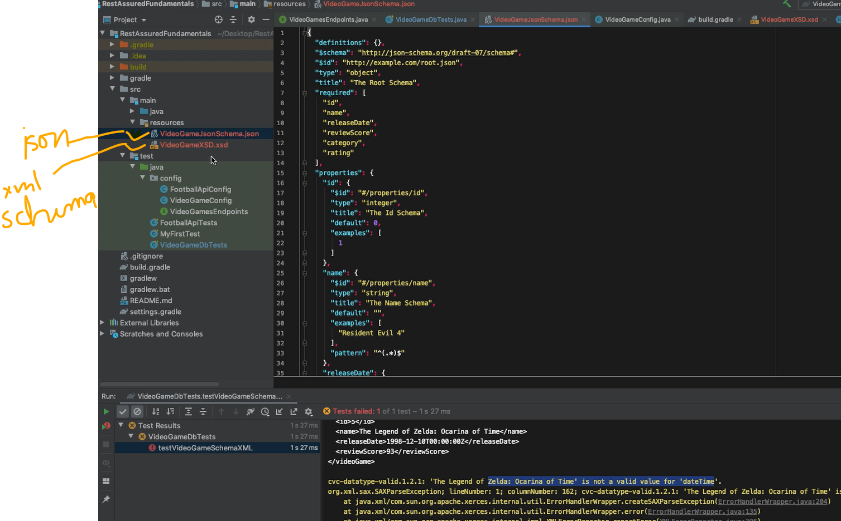

Run the test

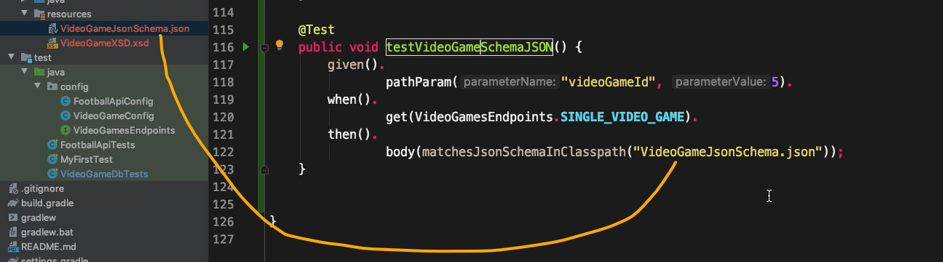

**Convert json response to POJO**

Add empty constructor to Class.

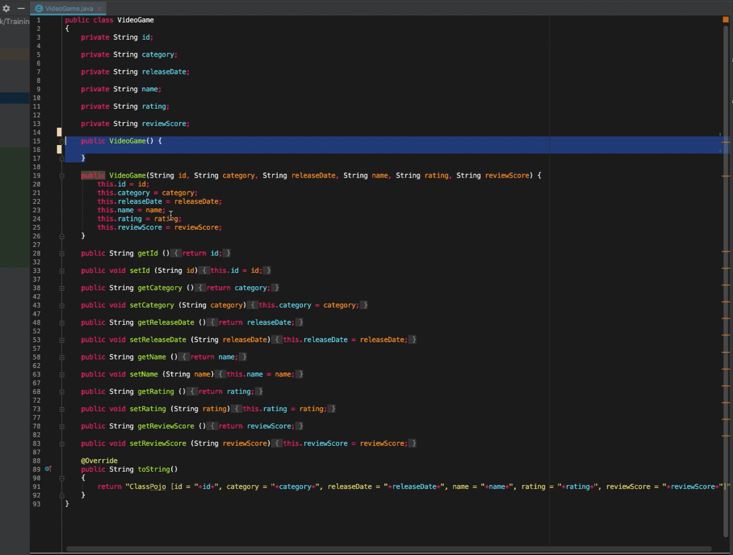

Convert the json res to POJO

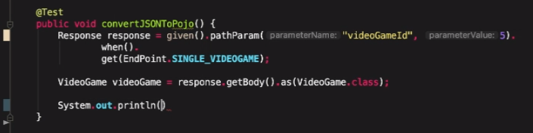

**\*\* Assert Response time**

Validate the response time at the test level

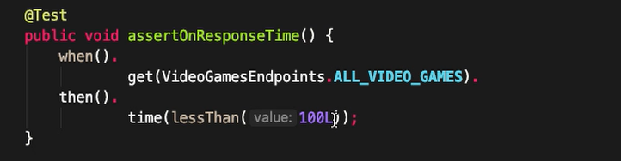

Validate the response time for all the responses. Validate in the super class

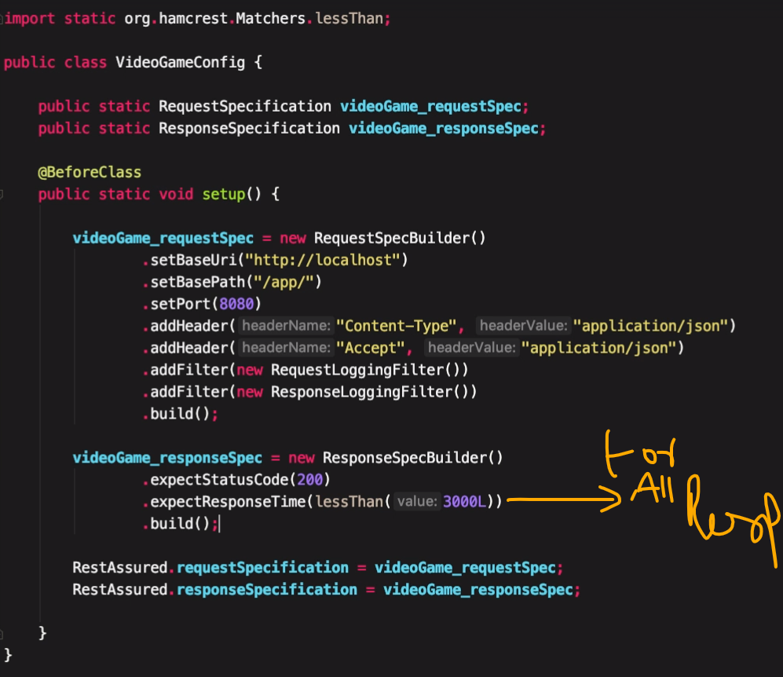

Important link

[**https://www.james-willett.com/rest-assured-gpath-json**](https://www.james-willett.com/rest-assured-gpath-json)

**\*\* Basic authentication and Basic challenged Auth**

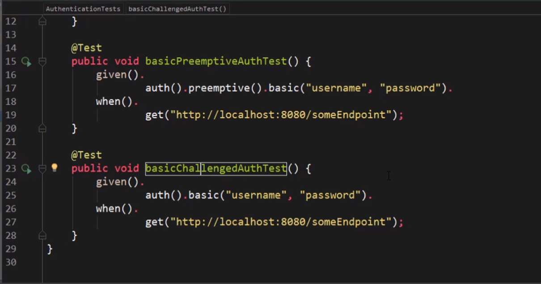

**\*\* oAuth and oAuth2**

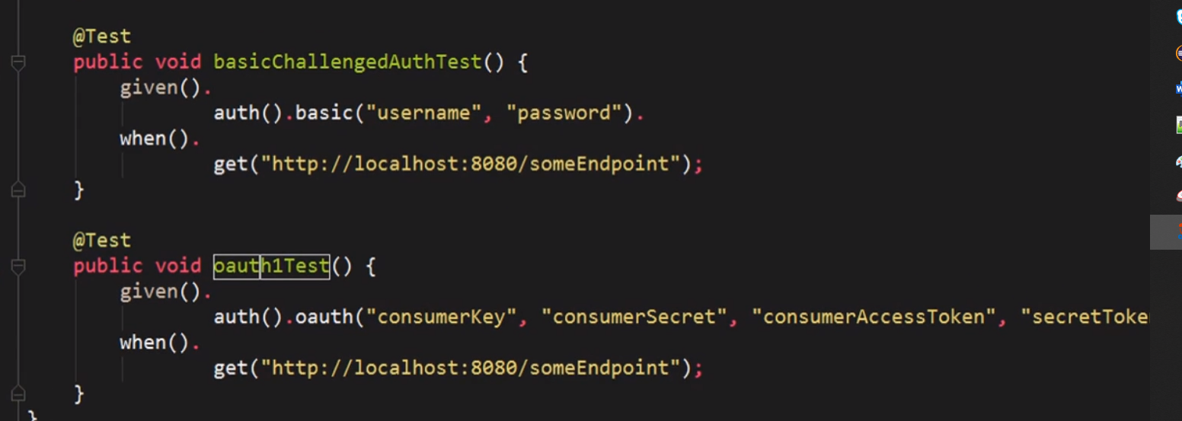

**SSL Validation when it comes to https validation:**

RestAssured.config = RestAssured.config().sslConfig(sslConfig().relaxedHTTPSValidation());

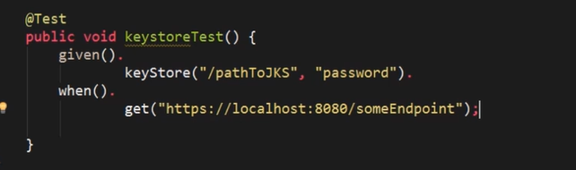

**\*\*Validating XML Responses:**

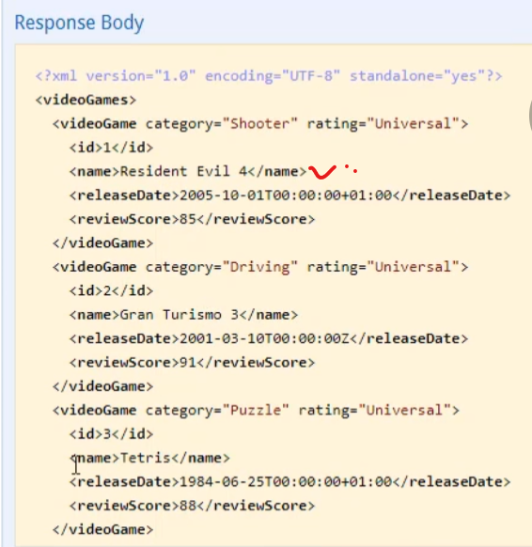

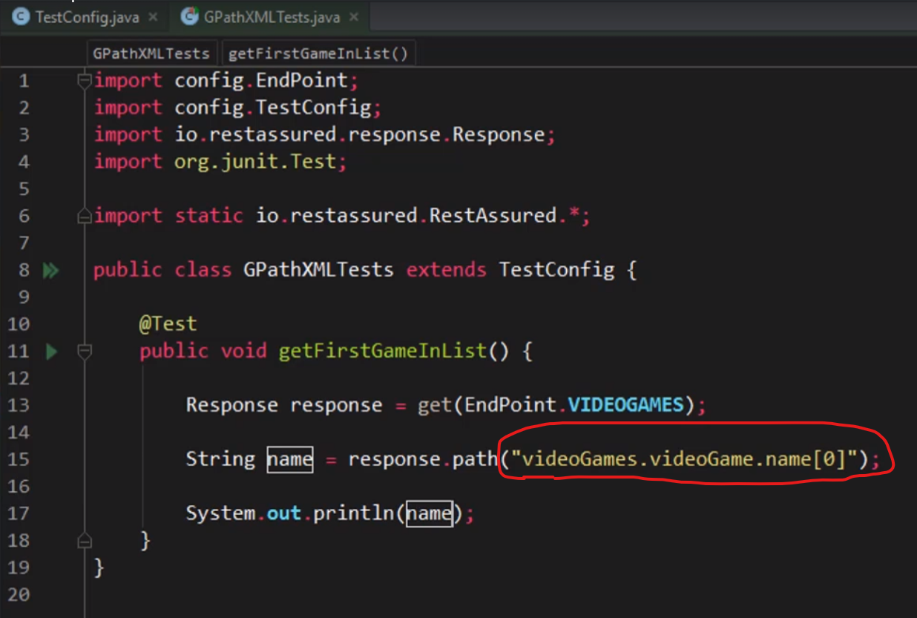

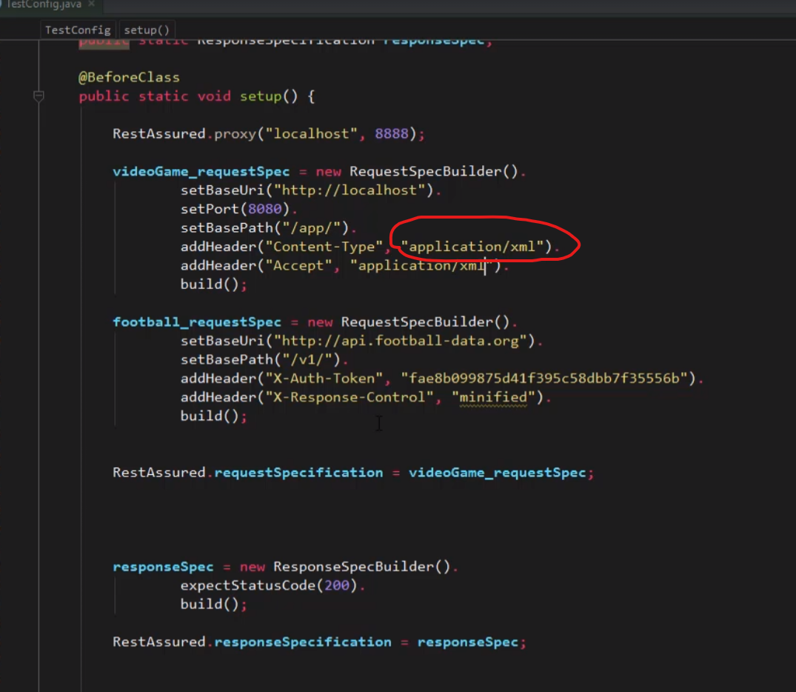

**Validating xml attributes:

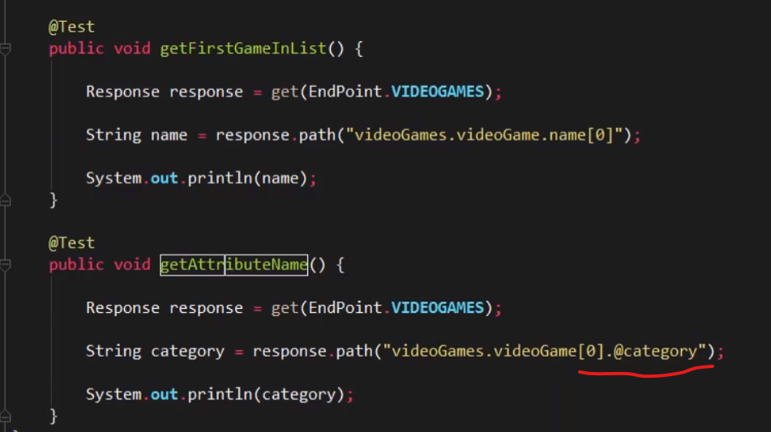

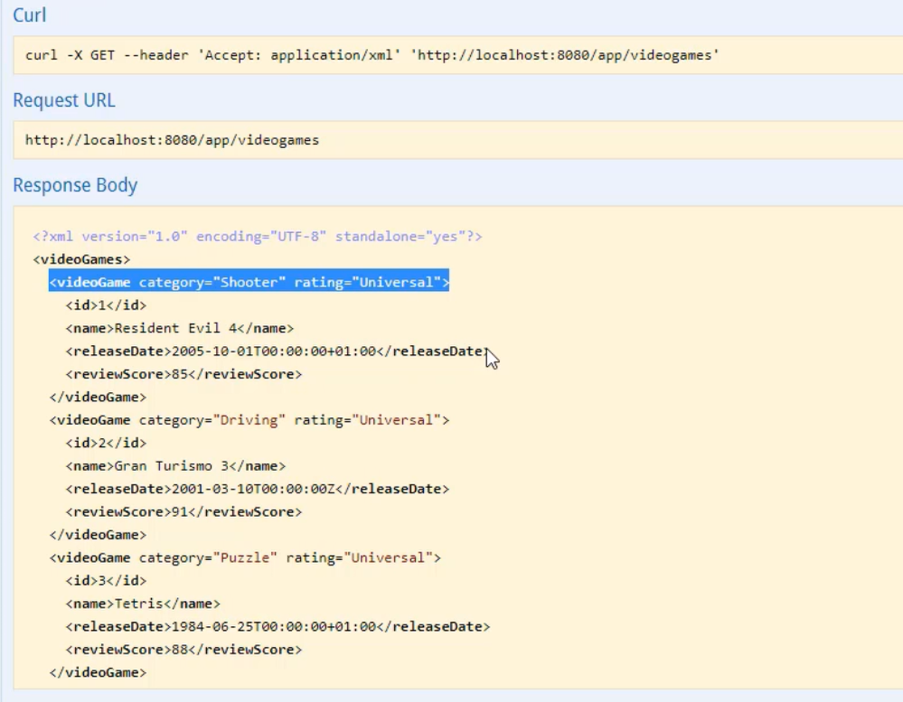

**\*\* FindAll**

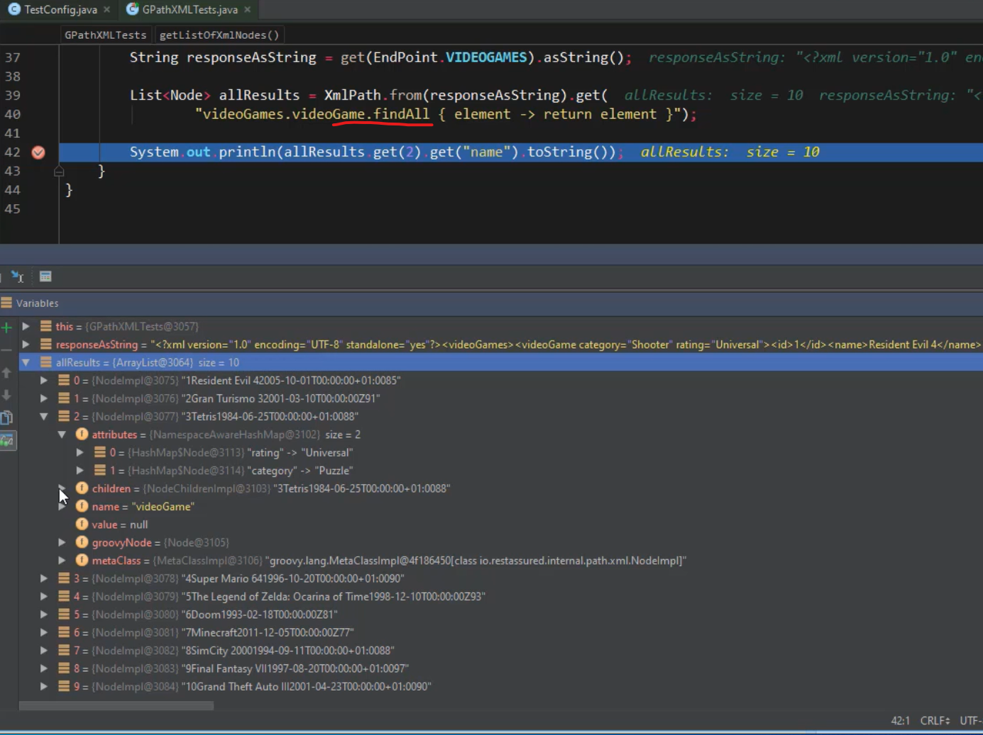

**Extract all nodes having specific attribute

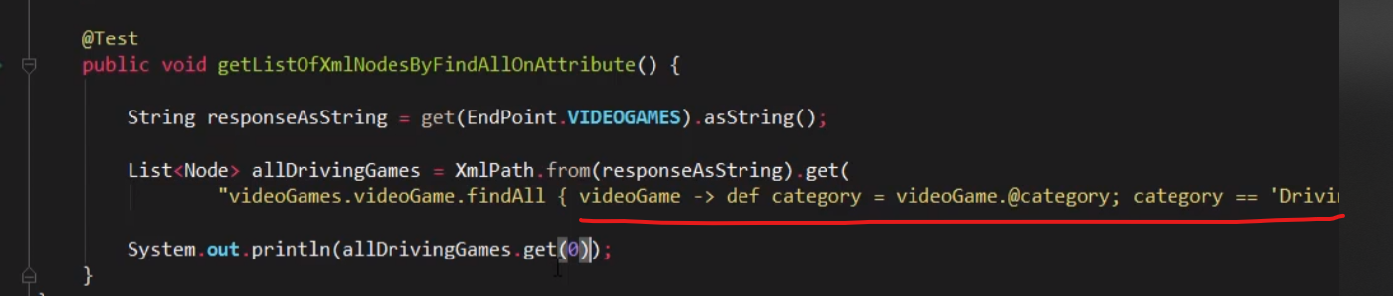

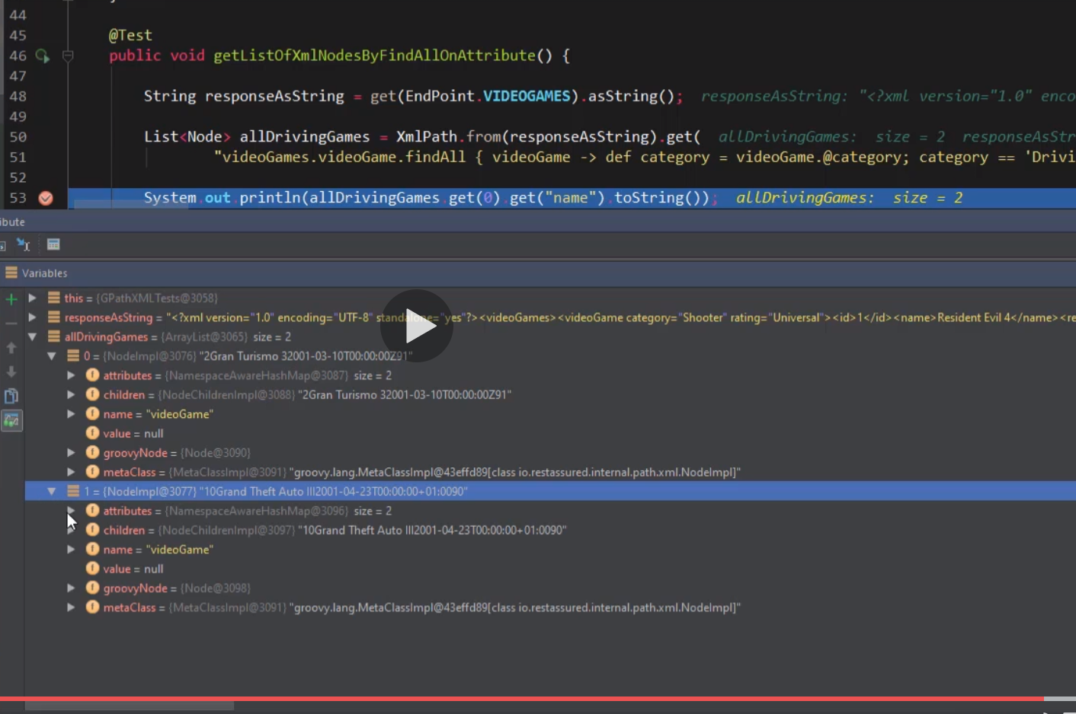

**\*\*Extract single node**

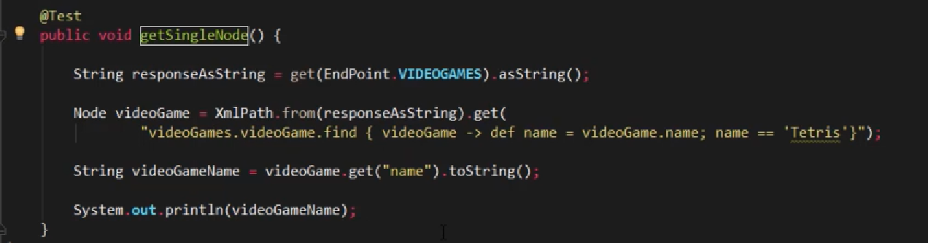

**Depth First search in xpath

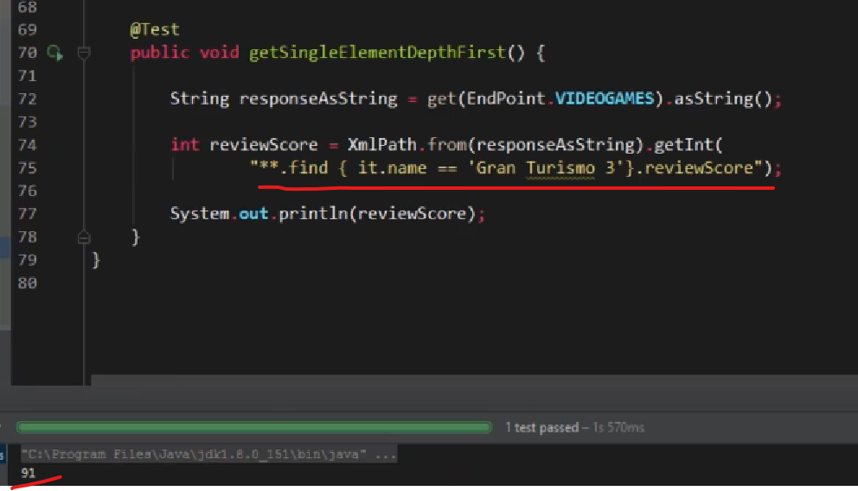

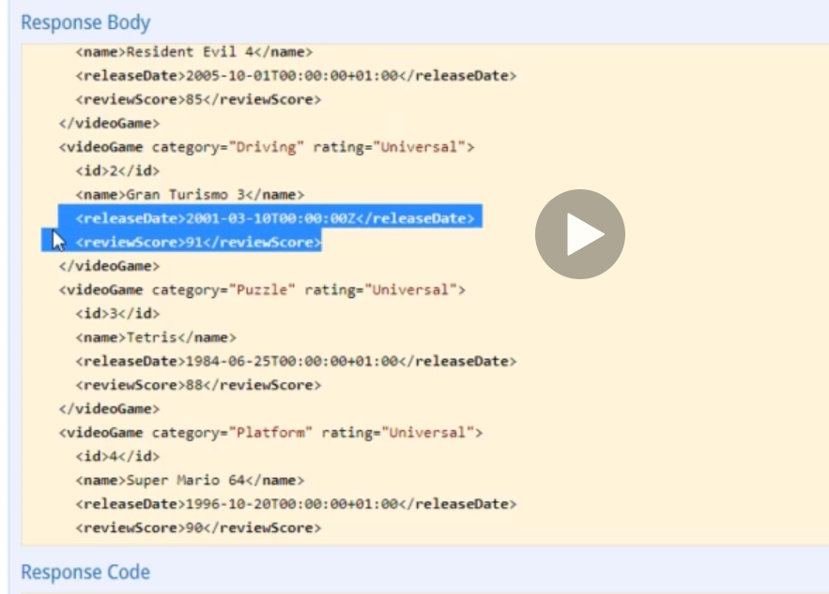

**FinadAll nodes based on a condition

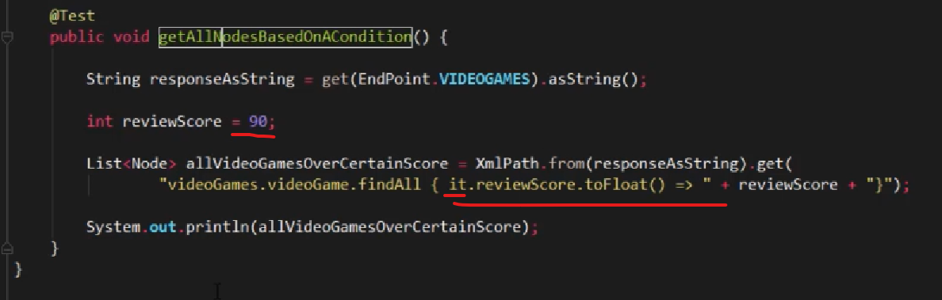

Find all games which has review score > 90